Algorithm For Even Odd Program

1. Step 1- Start the program.
2. Step 2- Read/input the number.
3. Step 3- if n%2==0 then the number is even.
4. Step 4- else number is odd.
5. Step 5- display the output.
6. Step 6- Stop the program.

Pseudocode

1. INPUT n.
2. remainder = n % 2.
3. IF remainder is not equal to 0.
4. answer = odd.
5. ELSE
6. answer = even.
7. OUTPUT answer.

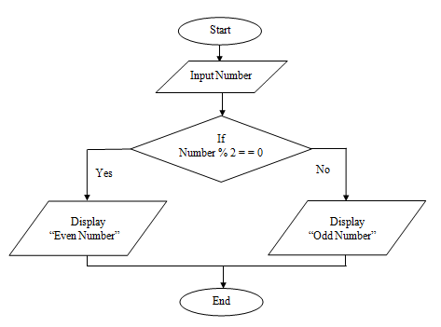

Algo for prime number

1.Read the number N

2. start the loop from i= 2 to i=N-1

3.If N is divided by "i" in the loop then break the loop

4.If(i==N) # that means loop has executed till the end of range so N is not divided by any number So it is a prime number

5.Else it is not a prime number

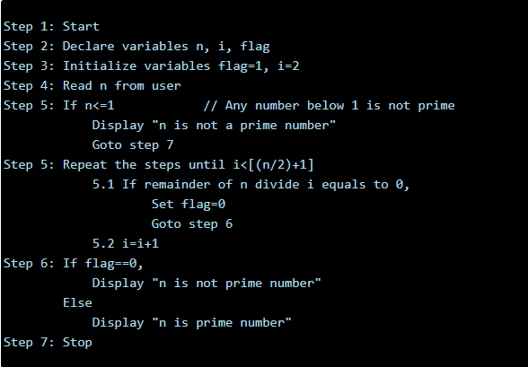

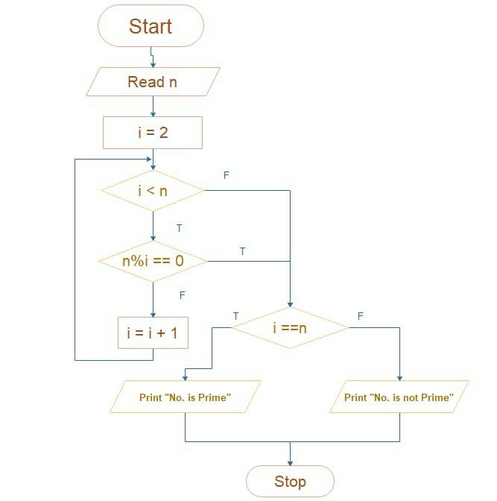

Display all even numbers from 1 to 10

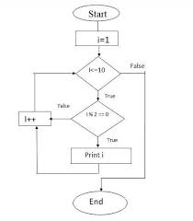

Start

2. Declare a count variable (to keep track of number of even number printed)

3. Run a for loop from 1 to 100 (say 100)

4. Check if count has reached the number of even number printed as 10. If exceeds break

5. Check if the current number in the loop is divisible by 2

6. If yes, then increment the count  and print the current number. Otherwise go to the next iteration.

7. Stop

1. for each number from 1 to 30 do
2. if the number is even then
3. print the number
4. end if
5. end for